Assignment No-3

Problem Statement

You work for XYZ Corporation. Your team is asked to deploy similar architecture multiple times for testing, development, and production purposes. Implement CloudFormation for the tasks assigned to you below.

Task to be performed:

• Use the template from CloudFormation task 1.

• Add Notification to the CloudFormation stack using SNS so that you get a notification via mail for every step of the stack creation process.

Solution:

Go to Amazon Simple Notification Service.

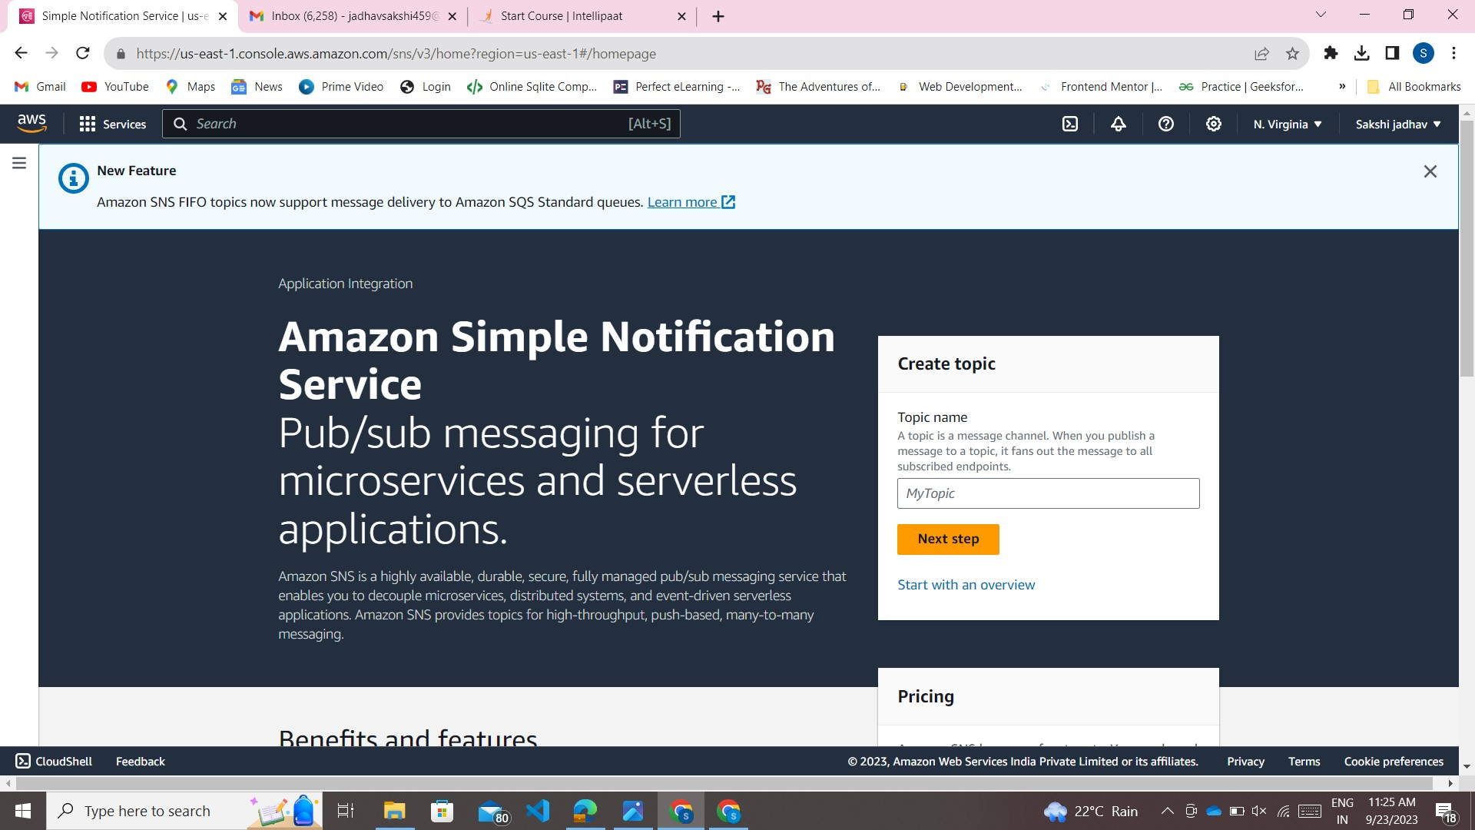

Go and Create Topic and Give it a Name.

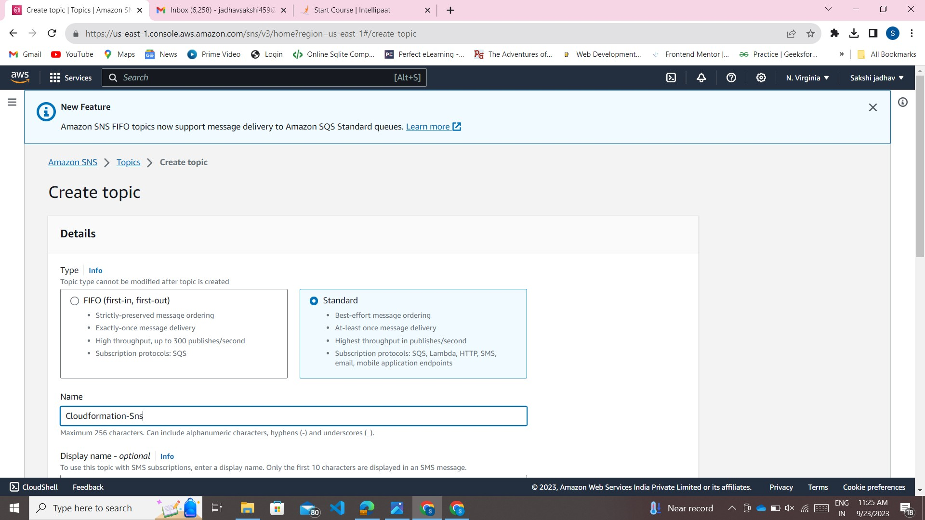

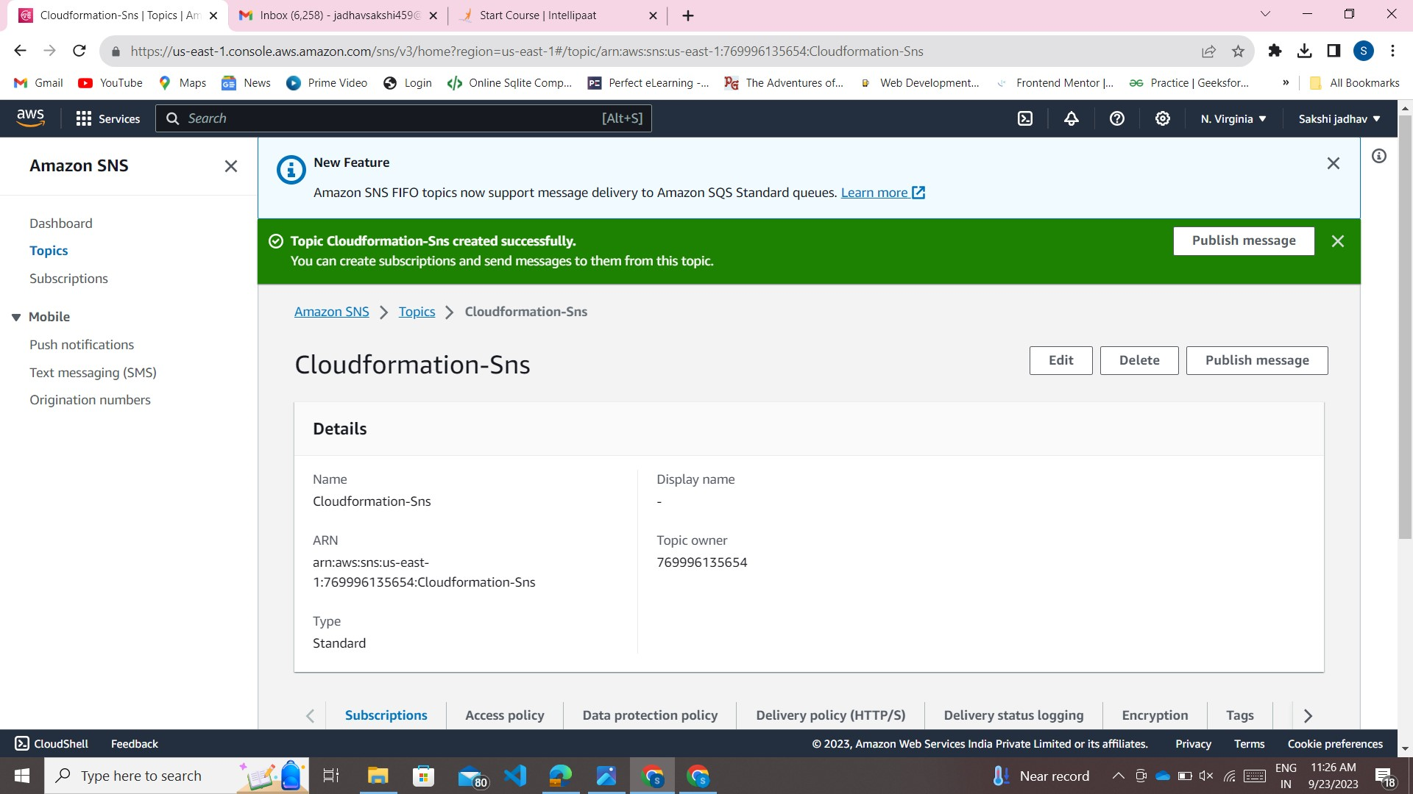

Create Subscription

